G. Fun Facts
- Perpetual Motion: The First Law rules out "Perpetual Motion Machines of the First Kind" (machines that produce energy from nothing). The Second Law rules out "Second Kind" (machines that convert heat perfectly into work without loss). Thermodynamics is the "No Free Lunch" science.
- Arrow of Time: Entropy is the only physical quantity that gives time a direction. All other laws of physics works the same forwards and backwards. Entropy only increases forward.
- Death of the Universe: The "Heat Death" theory suggests the universe will end when entropy is maximized-no heat flows, no work can be done, everything is a uniform lukewarm soup.
- Human Engines: The human body is about $25\%$ efficient at converting chemical energy (food) into work. Cars are about $20-30\%$. We are living combustion engines!
- Absolute Zero: You can never reach 0 Kelvin (Third Law). You can get infinitely close (picokelvins), but never exactly zero.
- Maxwell's Demon: A famous thought experiment where a tiny demon sorts fast and slow molecules to violate the Second Law. Information theory later proved the demon uses energy to "record" the molecules, saving the Second Law.
- Diamond vs Graphite: Diamond is thermodynamically unstable compared to graphite! Diamonds are slowly turning into graphite, but the process takes millions of years (kinetically stable).
- Negative Temperature: In quantum systems (lasers), you can have "negative absolute temperatures," which are actually hotter than infinite positive temperature. Thermodynamics gets weird at the quantum level.
- Information is Entropy: Shannon Entropy connects thermodynamics to computer science. Deleting a file actually releases a tiny amount of heat!
- Boltzmann's Grave: The equation $S=klog⁡W$ is carved on Ludwig Boltzmann's tombstone. It connects the micro-world (W) to the macro-world (S).
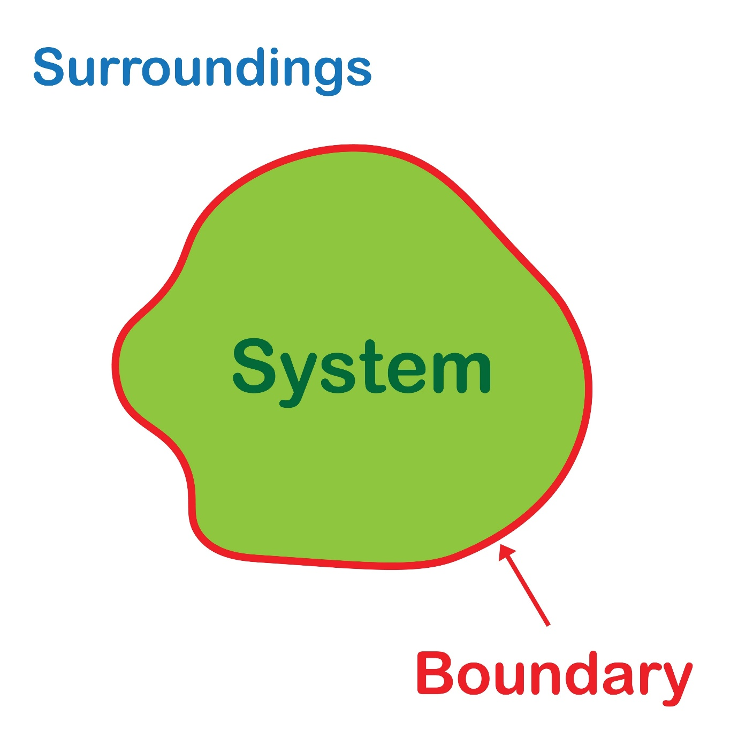
This unit is often considered the "mathematical backbone" of physical chemistry. Equilibrium teaches us that reactions don't just stop-they reach a state of balance. This chapter is divided into two distinct halves: Chemical Equilibrium (dealing with molecules) and lonic Equilibrium (dealing with ions, acids, and bases).
Unit 6: Equilibrium

